Book

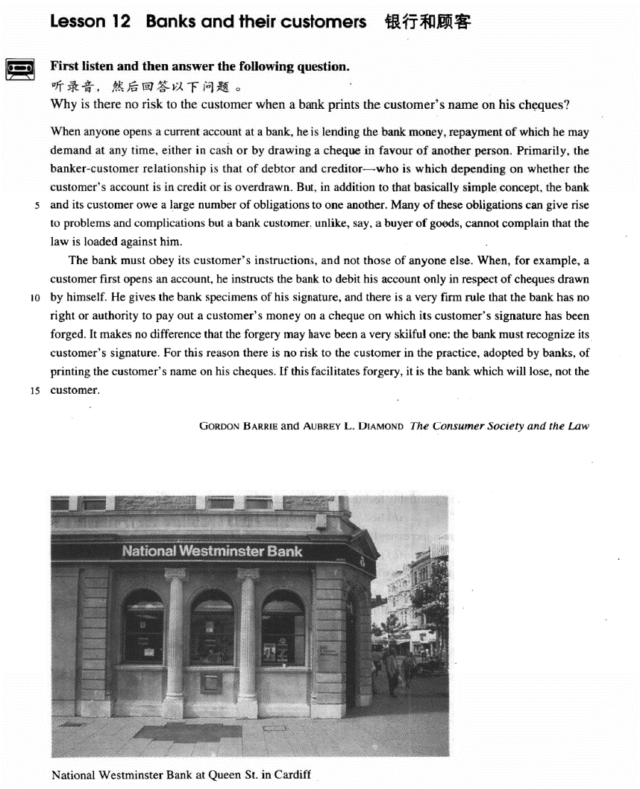

课文

When anyone opens a current account at a bank, he is lending the bank money, repayment of which he may demand at any time either in cash or by drawing a cheque in favour of another person.

任何人在银行开一个活期账户，就等于把钱借给了银行。这笔钱他可以随时提取，提取的方式可以是取现金，也可以是开一张以他人为收款人的支票。

Primarily, the banker-customer relationship is that of debtor and creditor -- who is which depending on whether the customer's account is in credit or is overdrawn.

银行与储户的关系主要是债务人和债权人的关系。究竟谁是债务人谁是债权人，要看储户是有结余还是透支。

But, in addition to that basically simple concept, the bank and its customer owe a large number of obligations to one another.

除了这一基本的简单的概念外，银行和储户彼此还需承担大量义务。

Many of these obligations can give rise to problems and complications but a bank customer, unlike, say, a buyer of goods, cannot complain that the law is loaded against him.

其中许多义务往往引起问题和纠纷。但是储户不能像货物的买主那样来抱怨法律对自己不利。

The bank must obey its customer's instructions, and not those of anyone else.

银行必须遵照储户的嘱托办事，不能听从其他人的指令。

When, for example, a customer first opens an account, he instructs the bank to debit his account only in respect of cheques drawn by himself.

比如，储户首次在银行开户时，嘱咐银行他的存款只能凭本世人签字的支票来提取。

He gives the bank specimens of his signature, and there is a very firm rule that the bank has no right or authority to pay out a customer's money on a cheque on which its customer's signature has been forged.

他把自己签名的样本交给银行，对此有一条非常严格的规定：银行没有任何权利或理由把储户的钱让伪造储户的支票取走。

It makes no difference that the forgery may have been a very skillful one: the bank must recognize its customer's signature.

即使伪造得很巧妙，也不能付款，因为银行有责任辨认出其储户的签名。

For this reason there is no risk to the customer in the practice, adopted by banks, of printing the customer's name on his cheques.

因此，某些银行已采用把储户印在支票上的作法。这种做法对储户毫无风险。

If this facilitates forgery, it is the bank which will lose, not the customer.

如果因这种作法出现了伪造的话，受损失的将不是储户，而是银行。

词汇讲解

Lesson 12 Banks and their customers

current ['kʌrənt]

adj. 当前的，现在的，流行的

current problems

current events / affairs

the current president

|  |
| --- |
| Current account |
| Checking account |
| Savings account |
| Deposit account |

open an account close an account deposit / bank

You’d better deposit / bank your money. draw / withdraw … from …

take … out of …

He drew / withdrew $100 from his bank (account). He took $100 out of his bank (account).

overdraw

My account is overdrawn by $200. cash / encash

to cash / encash a check debtor ['detə(r)]

adj. 债务人，借方

debtor n. person who owes money to sb. 债务人，借方creditor n. person to whom money is owed 债权人，贷方debit v. 把……计入借方，记上客户支出的钱

Debit $100 against Mr. Smith’s account. Debit Mr. Smith’s account with $100.

debit n. 账户的借方；账户中提取的款项

credit v. 把……计入贷方，记上客户存入的钱

Credit Mr. smith’s account with $100.

credit n. 账户的贷方；账户中存入的款项

Your account is in credit. obligation [7ɒblɪ'geɪʃn]

adj. 责任，义务

obligation to n. / to do sth

America’s obligation to its allies

Employers have an obligation / are under an obligation to treat all employees equally.

meet / honor / fulfill one’s obligation sense of obligation

legal obligation

moral obligation

mutual / reciprocal obligation duty

obligation responsibility complication [7kɒmplɪ'keɪʃn]

n. 复杂的情况，纠纷

complications between two parties / countries

legal complications avoid complications cause complications

produce further complications

If diabetes is not treated properly, complications will set in. complicate complicated

“plic” = fold implicate

He was implicated *in* the crime. explicate

The teacher is explicating an abstruse poem.

duplicate

He duplicated his former mistakes. supplicate

I supplicated her forgiveness. specimen ['spesɪmən]

adj. 样品，标本

specimen sample

a specimen / sample signature a blood specimen / sample

a urine specimen / sample

samples of a new shampoo adopt [ə'dɒpt]

v. 领养；采取，采用；正式批准

adopt an orphan adopted son adoptive parents foster-parents adopt a new idea

adopt a new technique

The Senate unanimously adopted the committee’s proposals. adoption n. 领养；采纳，采用

This textbook has adoptions in many countries.

adept adj. 熟练的，内行的

be adept at / in …

adapt v.（使）适应；改编

She quickly adapted *to* the new climate. The movie was adapted *from* a novel. facilitate [fə'sɪlɪteɪt]

v. 使某事更容易

Modern devices facilitate domestic work.

facility n.（常用复数）（使事情便利的）设备，设施 drainage facilities

medical facilities recreational facilities public health facilities lodge and eating facilities

facile adj. easily obtained or achieved (and so not highly valued) 容易得

到的（因而没有太大价值的）

a facile success “fac” = make

manufacture benefactor malefactor “-ile” 易于的

fertile

fragile

facile (“fac” + “ile”)

When anyone opens a current account at a bank, he is lending the bank money, *repayment of which he may demand at any time, either in cash or*

*by drawing a cheque in favour of another person*. lend sth. to sb.

lend sb. sth. loan sth. to sb. loan sb. sth.

borrow sth. from sb. √ borrow sb. sth. X

你能不能借给我 100 块钱？

Would you borrow me ￥100? X Would you lend me ￥100? √ Would you lend ￥100 to me? √ May I borrow ￥100 from you? √

May I borrow you ￥100? X

when anyone …, he is …

无论是谁（做某事），就等于在……

造句：无论是谁试图徒步穿越这个山口，就等于在生命冒险。

When anyone tries to cross the pass on foot, he is risking his life. “名词+介词+关系代词” 引导非限定性定语从句

This echo-location in bats is often compared with radar, the principle of

which is similar.

The most valuable find of all was the ship's log book, parts of which it was still possible to read.

the repayment of debt repay sb. sth.

repay sth. to sb. pay sb. back pay back sth.

I’ll pay you back tomorrow. pay off one’s debts

clear one’s debts give sb. a refund

We’ll give you a refund if you’re not entirely satisfied. reimburse sb.

Pay for the hotel room when you leave, and the company will reimburse

you later.

in favor of …（支票）以某人/某部门为受款人

Checks should be written / drawn in favor of New Oriental School. Primarily, the banker-customer relationship is that of debtor and creditor—who is which *depending on whether the customer's account is*

*in credit or is overdrawn*.

|  |  |
| --- | --- |
| Primarily | Mainly |
| Principally | Largely |
| Chiefly | Above all |
| First and foremost | |

heart and soul knife and fork

Please pass me pencil and paper.

the relation between teacher and student the conflict between mother and son

He worried about if he had hurt her feelings. X

He worried about whether he had hurt her feelings. √ be overdrawn = be in the red

Your account is overdrawn / in the red. in addition to …

besides …

as well as … together with … along with … apart from … aside from … owe sth. to sb. owe sb. sth.

owe obligations to sb. have obligations to sb.

Parents owe / have obligations to their children. I owe you (a lot).

You owe him an apology. You owe him an explanation.

Many of these obligations can give rise to problems and complications but a bank customer, *unlike, say, a buyer of goods*, cannot complain that the law is loaded against him.

give rise to …

The president’s absence has given rise to speculation about his health. This can give rise to curious situations, as it did in the case of Alfred Bloggs who worked as a dustman for the Ellesmere Corporation.

cause … lead to …

result in … bring about … effect …

set up …

The slump on Wall Street set up a chain reaction in stock markets around the world.

produce / create / generate

His announcement produced / created / generated gasps of amazement. trigger / spark / precipitate

One small error triggered / sparked / precipitated the calamity.

sth. is loaded against … used to say that a system, situation, or organization is unfair and some people have a disadvantage 对……不公平

The justice system is loaded against ethnic minorities.

be prejudiced against … be biased against …

The early Christian church was prejudiced / biased against Jews.

The fact that the policeman was prejudiced against foreigners could not be recorded in the official files.

be biased in favor of … be partial to …

The decision was biased in favor of / partial to the plaintiff.

obey instructions take instructions follow instructions await instructions

When, for example, a customer first opens an account, he instructs the bank to debit his account *only in respect of cheques drawn by himself*.

US foreign policy in respect of with respect to with regard to concerning

regarding respecting

He gives the bank specimens of his signature, and there is a very firm rule that the bank has no right or authority to pay out a customer's money on a cheque on which its customer's signature has been forged.

signature autograph

I’ve got lots of famous actors' autographs. sign

Where do you want me to sign my name? sign for …

Could you sign for this package, please?

initial

The memo has been initialled / initialed by the president. authority n. [U] right to act in a specific way 职权，权限Only the treasurer has authority to sign checks.

pay out: to pay a lot of money for something 支付（大笔的钱）

We’re paying out $300 a month on our mortgage. make a difference

make some difference make no difference

For this reason there is no risk *to the customer* in the practice, *adopted by banks*, of printing the customer's name on his cheques.

|  |  |
| --- | --- |
| For this reason | so |
| Thus | Hence |
| Therefore | Thereupon |
| Ergo | Accordingly |
| As a result | Consequently |
| As a consequence | In consequence |

the risk *of* serious injury There is no risk *to* customers.

practice n. 习惯性的做法，惯例

the practice of doing sth.

the practice of closing shops on Sundays the practice of dumping waste into the sea

If this facilitates forgery, it is the bank which will lose, not the customer. facilitate …

ease / smooth the way for …

The agreement will ease / smooth the way for other countries to join the EU.

it is … that / who(m) …

it is … which …（尤其用于科技、说明文体） It is heat which makes matter expand and melt.

It is the release of nuclear energy within the Sun which enables it to send out so much energy to the earth.

if …, it is … that / which / who(m) …, not …

If this facilitates forgery, it is the bank which will lose, not the customer. If there is one—which I take leave to doubt—then it is older people who create it, not the young themselves.